COSC 412

Individual Project

Zeeshan Haider

**Preface**

The purpose of this project is to create an information website for a small business Gas station. The website will be designed basically help people with more information regarding a Shell gas station. The website will provide, location, gas price and gas types, what in-store items are sold, in-store pictures and other miscellaneous info but the most important thing would be that you would be able to order the items you want to purchase from the web and they will be ready for pick up. The website will most be information based and the functional part would be putting in orders for pickup.

**Table of Contents**

1. Introduction

1.1 Overview

1.2 Deliverables

1.3 Evolution of SPMP

1.4 References Materials

1.5 Definitions and Acronyms

2. Project Organization

2.1 Process Model

2.2 Organizational Structure

2.3 Organizational Interface

2.4 Project Responsibilities

3. Managerial Process

3.1 Management Objectives and Priorities

3.2 Assumptions, Dependencies and Constraints

3.3 Risk Management

3.4 Monitoring and Controlling Mechanisms

4. Technical Process

4.1 Methods, Tools, and Techniques

4.2 Software Documentation

4.3 Project Support Functions

5. Work Elements, Schedule, Budget

5.1 Work Breakdown Structure

Introduction

1.1 Overview

* 1.2 Deliverables
  + Repository Setup September 9th
  + SPMP October 10th
  + Requirements – Use Cases October 10th
  + Proposed tools October 10th
  + Final Project November 13th
  + Final Project Presentation November 24th
* 1.3 Evolution of SPMP
* 1.4 Reference Materials
* 1.5 Definitions and Acronyms

Project Organization

2. Project Organization

2.1 Process Model

Agile development, changes will be updated regularly and would be focused more on design.

2.2 Organizational Structure

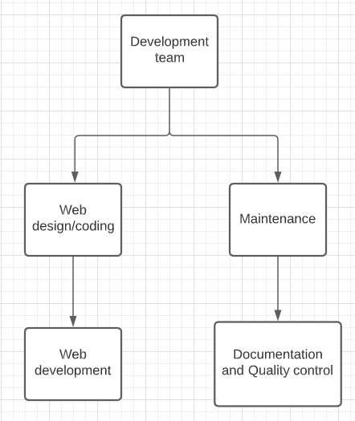

2.3 Organizational Interface

2.4 Project Responsibilities

Managerial Process

3.1 Management Objectives and Priorities

* Complete deliverables on time
* Detailed documentation

3.2 Assumptions, Dependencies and Constraints

* Assumptions/Dependencies
  + Have the resources to work on the project
  + Dependent on client for information
* Constraints
  + Time: We have until the end of November to finish a working prototype.
  + Scope: documentation of project process

3.3 Risk Management

* Meetings with Professor to assure the project plan
* Will take into consideration every new development idea of our program if it is feasible.
* If the project becomes too complex, we will need to reevaluate the project to ensure that we are on the right track

3.4 Monitoring and Controlling Mechanisms

* Project Documentation Updates
* Github commits
* Status and check-ins with prof

Technical Process

4.1 Methods, Tools, and Techniques:

* Languages: HTML, CSS, JavaScript
* Database: HostGator
* Version Control: Git
* Frameworks: Word press
* Web hosting: HostGator

4.2 Software Documentation

* Documentation for project related information is available for client/stakeholders to look over and discuss changes.
* From the start to finish, the documentation goes over different aspects of the projects such as: requirements, test plans, test documentation, system documentation, and the final report.

4.3 Project Support Functions

Quality assurance:

* Software Testing:
  + Test plans
  + Test procedures
  + Integration testing
  + Acceptance (final test)
* Configuration control
  + Program code changes
  + Requirements and design changes

Work Elements, Schedule, Budget

